Comsats University Islamabad
(Attock Campus)

NAME | Abdul Haq
REG NO | SP24-BSE-033
SUBMITTED TO | MS AMBREEN GUL
ASSIGNMENT | 01
COURSE | INFORMATION SECURITY
DATE | 12-OCT-2025

QUESTION:
Write python code for your designed stream cipher approach for encryption decryption, you can use approach from more than one already developed ciphers as given in lab practice exercises.
Design and implement an adversarial attack approach for your proposed stream cipher approach.
STREAM CIPHER SCREENSHOTS:
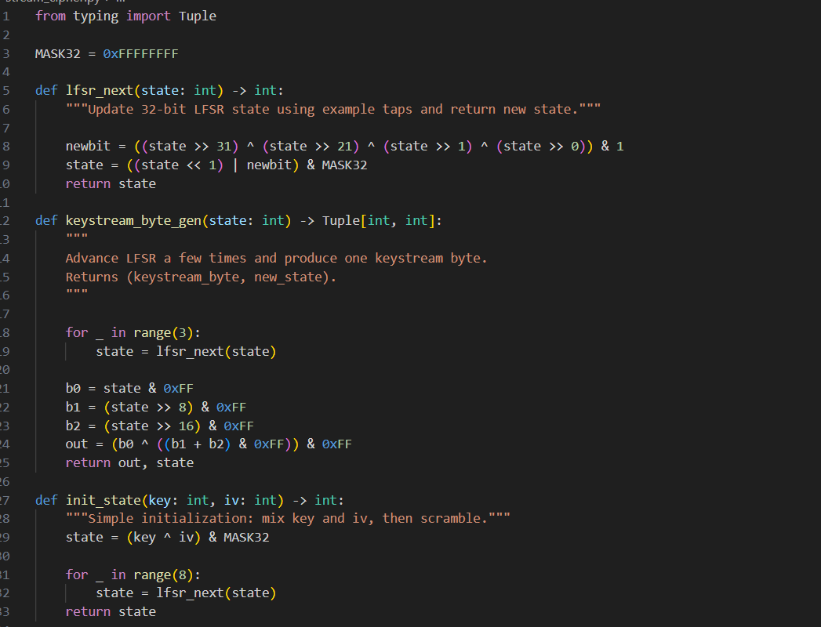
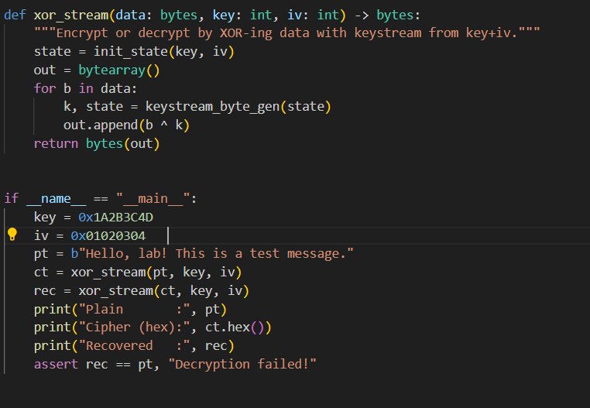
OUTPUT:
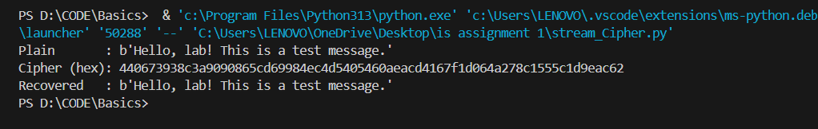
ATTACK REUSE SCREENSHOTS:
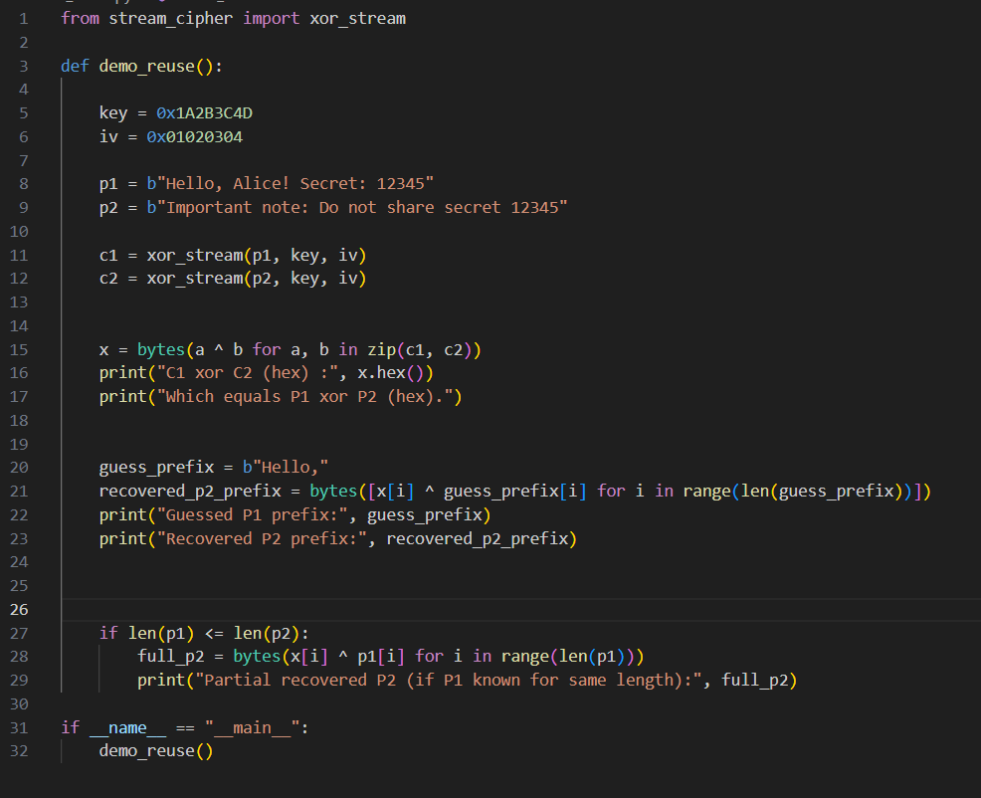
OUTPUT:
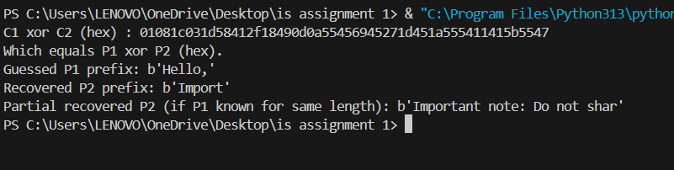

ATTACK BRUTE FORCE SCREENSHOTS:
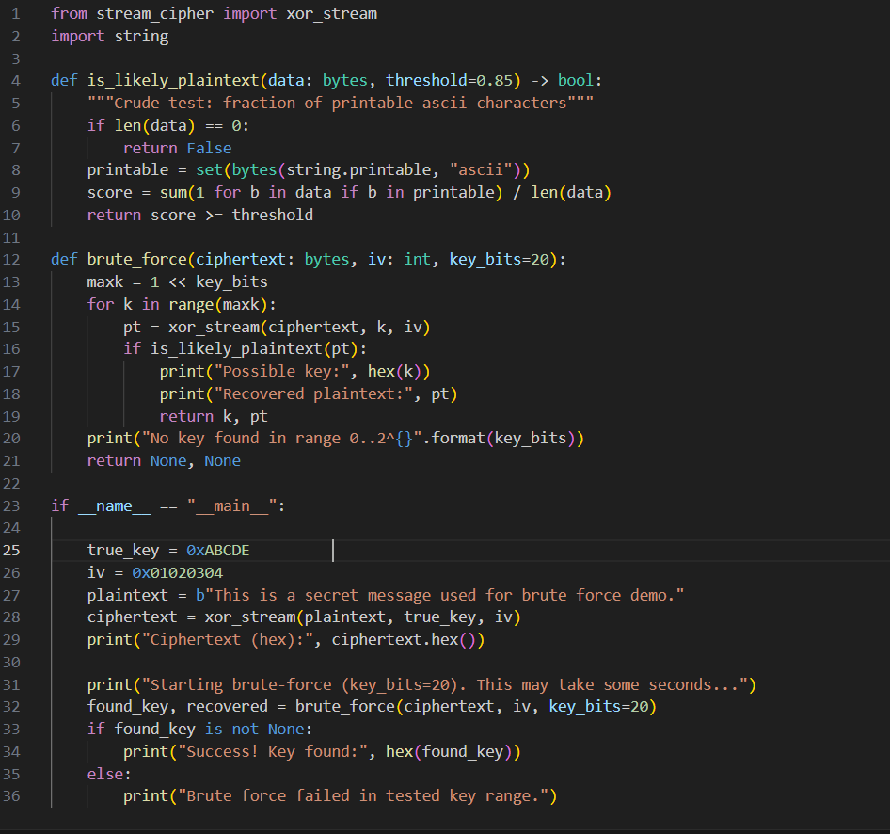
OUTPUT:
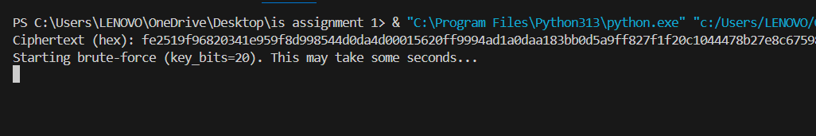
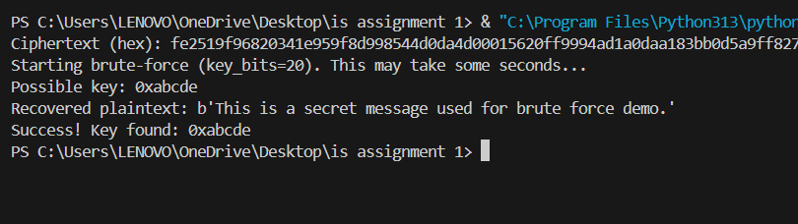

What this shows:
- The script encrypted a message with a small demo key (3 characters) and then tried every possible key in the small keyspace.
- The brute-force script checks decrypted results with a simple printable-ASCII test and checks for common words like "secret" or "message".
- When the test passes and readable text appears, the candidate key is printed.
- Success demonstrates that small keys are insecure because an attacker can try all possible keys until a readable plaintext appears.

Why the attacks work :

Keystream Reuse Attack:
If the same keystream is used for two messages, XOR-ing the two ciphertexts removes the keystream and results in the XOR of the two plaintexts:
C1 XOR C2 = (P1 XOR K) XOR (P2 XOR K) = P1 XOR P2
From P1 XOR P2, if an attacker knows or can guess parts of P1, they can recover parts of P2. Reusing a nonce/IV or reusing the keystream is a critical mistake.
Mathematical explanation:
- Ciphertext 1: C1 = P1 ⊕ K
- Ciphertext 2: C2 = P2 ⊕ K
- C1 ⊕ C2 = (P1 ⊕ K) ⊕ (P2 ⊕ K) = P1 ⊕ P2
- If attacker knows P1, then: P2 = P1 ⊕ (C1 ⊕ C2)

Brute-Force Small Keyspace:
If the key is small enough, an attacker can try all possible keys (exhaustive search). For each candidate key they decrypt and check if the result looks like readable plaintext — when it does, they have likely found the correct key.
Keyspace Analysis:
- 3 characters (lowercase): 26³ = 17,576 keys → Can be broken in seconds
- 4 characters (lowercase): 26⁴ = 456,976 keys → Still breakable quickly
- 8 characters (alphanumeric): 62⁸ ≈ 2.18 × 10¹⁴ keys → More secure but still vulnerable
- 16 bytes (128-bit): 2¹²⁸ ≈ 3.4 × 10³⁸ keys → Computationally infeasible to brute force
This is why keys must be large enough (e.g., 128 or 256 bits) in real systems.

Security Discussion
This simple cipher is not secure for real use:

Vulnerabilities:
- Linear State Evolution: The RC4-style state permutation is subject to cryptanalysis and has known biases.
- Weak Mixing: The cipher uses simple swapping without strong nonlinear operations.
- No Authentication: The cipher provides no integrity checking, making it vulnerable to tampering.
- Keystream Reuse: Using the same key for multiple messages is catastrophic.
- Small Key Support: The demonstration uses intentionally small keys for the brute-force demo, but even larger keys don't fix the fundamental design weaknesses.

Real Secure Alternatives:
Real secure stream ciphers use well-studied designs with strong nonlinear mixing and large keys:
- ChaCha20: Modern stream cipher with 256-bit keys
- AES-CTR: Block cipher in counter mode
- AES-GCM: Authenticated encryption providing both confidentiality and integrity
- ChaCha20-Poly1305: Stream cipher with authentication
Important: For any practical system, use a vetted cryptographic library (such as Python's cryptography library) rather than a home-grown cipher.

Conclusion
- I implemented a simple stream cipher combining RC4-style key scheduling with basic state permutation for keystream generation.
- I designed and demonstrated two adversarial attacks showing common failures:
  - Keystream reuse attack: Shows why never reusing keys/nonces is critical
  - Brute-force attack: Shows why small keyspaces are insecure
- The lab demonstrates fundamental principles:
  - Careful design with strong cryptographic primitives is essential
  - Large keys (minimum 128-bit) are necessary for security
  - Never reusing nonces/IVs is critical for stream ciphers
  - Authentication should be added to prevent tampering
  - Home-grown ciphers should never be used in production
- These attacks illustrate real vulnerabilities that have affected deployed systems historically (WEP protocol, RC4 in TLS, etc.)

Conclusion
- I implemented a simple stream cipher and two attacks showing common failures: keystream reuse and small keyspace brute-force.
- The lab demonstrates why careful design, large keys, and never reusing nonces are critical for secure encryption.

